A Three-Stage Cryogenic Pulse Magnet Program for BNL Targetry Experiment

Robert J. Weggel; BNL, bldg. 901A; Upton, NY 11973-5000
631-344-2428 (fax = 3248); weggel@bnl.gov

General Description of Magnet System

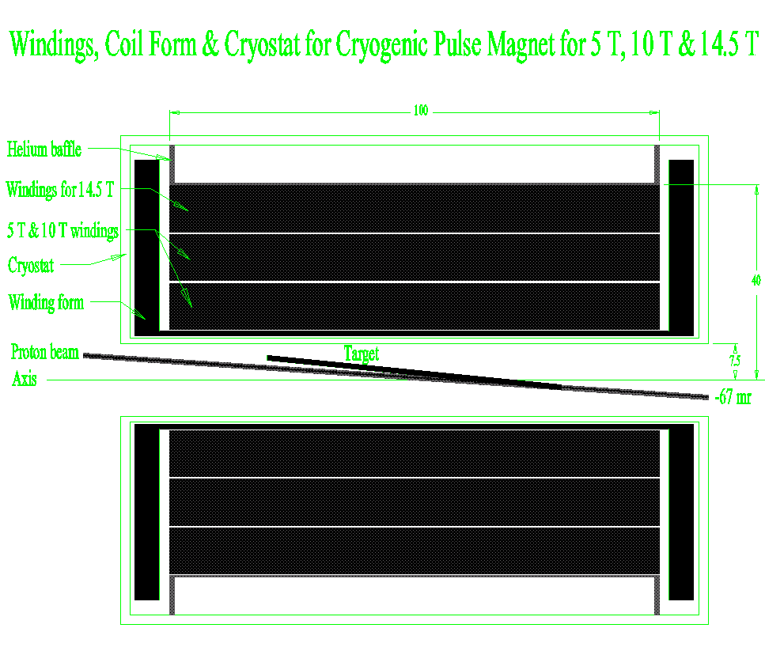

Fig. 1. Cross section of targetry magnet system: cryostat, magnet windings, target (mercury jet), and proton beam. The bore is 15 cm. The winding pack is of 100 cm length, 20 cm I.D., and 80 cm O.D. Channels for coolant separate the three subcoils, each of ~10 cm radial depth.

This report documents the conceptual design of a cryogenic pulse magnet to generate up to 14.5 teslas in a room temperature bore of 15 cm. The winding I.D., O.D. and length are 20 cm, 80 cm and 100 cm, respectively; the conductor is 3.6 metric tons (1,800 turns) of high-purity copper. Cooling of the magnet prior to each pulse is by helium gas or liquid nitrogen forced through axial channels in the magnet; recooling of the helium gas is by either liquid nitrogen or liquid hydrogen in a heat exchanger inherited from the SSC. To hasten cooldown of the magnet, it includes coolant channels not only at its inner and outer radius, but also at two intermediate radii.
At the outer of these radii (30 cm) is an additional current lead, to allow operation with the outermost coil omitted from the electrical circuit. The remaining magnet, of 60 cm O.D. and 1,200 turns, is appropriate for liquid-nitrogen operation; the full magnet has too high a resistance to reach full current unless cooled to less than ~34 K. The option to energize just the 1,200-turn magnet enables a staged approach to the full-field mode of operation. One can postpone fabrication of the outermost coil until needed by the last of the three stages that we propose.

Three Proposed Stages: 5 T, 10 T & 14.5 T

Fig. 2. Field versus time for cryogenic pulse magnet for BNL targetry experiment upon completion of each of three stages culminating in 14.5 tesla operation. Stage 1: 1,200 turns, 0.54 MVA; Stage 2: 1,200 turns, 2.16 MVA; Stage 3: 1,800 turns, 2.16 MVA.

Figure 2 graphs the field versus time for the three proposed modes of operation. Stage 1 employs the 1,200-turn magnet cooled to 86 K or less by liquid nitrogen at barely above atmospheric pressure (77-78 K). The power supply is one of many at BNL that is rated at 3.6 kiloamperes and 150 volts (540 kVA). At this voltage, the magnet takes about seven seconds to reach its full field of 5 T, which one holds for up to a second. Discharge at full negative voltage, –150 V, takes an additional three seconds.
Stage 2 employs the same 1,200-turn magnet, but energized by four BNL power supplies in series/parallel: 7.2 kA x 300 V = 2.16 MVA. The pulse is about 10% shorter than for Case #1. Simultaneously doubling both the current and the voltage calls for a magnet of the same resistance at peak current as Case #1. However, because of the fourfold increase in peak power, the magnet heats up nearly four times as much more during each pulse; therefore, it must start from a lower temperature—no more than 75 K. To reach this temperature, one can employ evaporative cooling at reduced pressure to subcool the nitrogen to within a few degrees of its 64 K freezing point. BNL has roughing pumps ample to accomplish this. Cryogenic investments will be in hardware and engineering associated with the SSC heat exchanger and cryogen delivery systems. Investments in the power supply will be hardware and software to ensure that the four supplies share the load equally.
Stage 3 employs the same 2.16 MVA power supply as Case #2, but now energizing all 1,800 turns. In order for the same 300 volts to suffice to drive full current through the much greater length of conductor, one must reduce its electrical resistivity by cooling it to ~30 K with helium gas whose temperature may be as low as 22 K. The heat sink is liquid hydrogen trucked to BNL from an industrial liquification plant. With 1½ times as many turns as Case #2, Case #3 generates 14.5 T instead of 10 T. The pulse is much longer than for the previous cases: ~15 seconds to full field, a flat top of about a second, and eight seconds to return to zero, when driven down at –300 V.
Table I tabulates parameters of Cases #1, #2 and #3. The last two rows give the temperature rise and cumulative heating for a typical pulse, in which, after a one second flat top, the power supply (“two-quadrant,” or “bipolar”) discharges the coil with negative voltage of the same magnitude used to charge the magnet.

Pulse Magnet Systems for E951 Targetry Experiment
 | Units | Case#1 | Case#2 | Case#3
Peak on-axis field | T | 5.0 | 10.0 | 14.5
No. of 0.54 MVA power supplies | - - | 1 | 4 | 4
Mode of ganging supplies | - - | None | 2 x 2 | 2 x 2
Initial temperature | K | 84 | 74 | 30
Number of turns utilized | - - | 1200 | 1200 | 1800
Charge time | sec | 7.2 | 6.2 | 15.2
Temperature rise at end of pulse | K | 6 | 21 | 48
Cumulative heating at end of pulse | MJ | 2.4 | 7.9 | 13.5

The remainder of this report supports the choice of magnet parameters of Table I. Each choice is to some extent subjective, involving judgment calls on the relative importance of costs and benefits. Of interest is the rate of change of each cost and benefit with a change in each magnet parameter. The following half dozen sections look at perturbations from a base-case design for each of the three stages of operation, examining the effects of just one or two parameters at a time.

How Long Should the Magnet Be?

An easy parameter to fix is that of magnet length, because the Targetry Experiment has a requirement for field homogeneity, which depends very strongly on magnet length and much less strongly on anything else. The field homogeneity is to limit the magnetohydrodynamic forces on the mercury jet target traversing the field; the field should be uniform to 10% over a length of 60 cm. Figure 3 reveals that the magnet should be about 100 cm long.

FigFig. 3. On-axis field profile of magnets of 80 cm outer diameter either 80 cm or 100 cm long. The longer magnet achieves the desired profile very well over the target, from –30 cm to +30 cm; the shorter magnet does not.

The “ideal field” in figure 3 is that which would retain quite well most of the pions captured in the 60 cm long target region, while transitioning to its much lower value in downstream components of a neutrino factory or muon collider. The field ramps downward by a factor of sixteen at three meters from the end of the magnet, while the bore increases by a factor of four. This field profile would allow one to test downstream components, such a radio-frequency cavity, in the intense shower of particles emanating from the target. Unfortunately, such a magnet is expensive in conductor and power supplies. In the present budgetary climate, the targetry experiment cannot afford a magnet with this field tail. Therefore, it no longer matters that beyond the target region, neither field profile matches very well the ideal field.

How Beneficial is Cryogenic Operation?

Fig. 4. Electrical resistivity ρ, heat capacity c_{p}, and ratio ρ/c_{p} between room temperature and 30 K, for copper with a residual resistivity of 0.05 μΩ cm below ~20 K.

The motivation to cryogenically cool any magnet, pulsed or not, is to improve the electrical conductivity of its conductor. Figure 4 shows that the resistivity of high-purity copper declines greatly from room temperature down to 30 K. The incentive to operate at cryogenic temperatures is great indeed. Cooling to 80 K (with liquid nitrogen at atmospheric pressure) improves the electrical conductivity by a factor of nearly seven. Cooling to 66 K (with liquid nitrogen subcooled to nearly its freezing point of 64 K) gives a ratio of about ten. Cooling to 30 K (with liquid hydrogen as the heat sink, for example) can achieve a ratio of about 30.

Fig. 5. Fig. Low-temperature electrical resistivity ρ (in zero magnetic field), heat capacity c_{p}, and ratio ρ/c_{p} for copper with a residual resistivity of 0.05 μΩ cm below 20 K.

There is very little incentive to operate at even lower temperatures; one has entered a regime of diminishing returns. Figure 5 illustrates two of the reasons for this. The electrical resistivity declines very little below 30 K. This is true even for copper that is exceedingly pure, unless it is so completely annealed as to be too weak for a very high field magnet. Also, the heat capacity of copper plummets very rapidly with decreasing temperature. Below ~50 K the ratio ρ/c_{p,} to which the heating rate of a conductor is proportional, increases—ever more rapidly—with decreasing temperature. In this range, the lower the temperature, the more rapidly a pulse magnet heats up. High-field pulse magnets rapidly heat up to temperatures above the minimum in the ρ/c_{p} curve. Only if one could remove heat from a magnet as fast as it is generated would the conductor continue to remain cold and conductive.
Furthermore, even if it were possible to keep the magnet very cold—to prevent it from warming up appreciably during each pulse—cold magnets suffer from another effect that can significantly degrade electrical conductivity at very low temperatures. This effect is magnetoresistance.

How detrimental is magnetoresistance?

Fig. 6. Electrical resistivity versus temperature from 20 K to 100 K and magnetic fields from zero to 20 T.

Magnetoresistance can be substantial at low temperatures and high fields. It becomes ever more significant at low temperature. Figure 6 graphs, as a function of temperature and magnetic field, the electrical resistivity of copper with a residual resistivity of 0.05 μΩ.cm.
Note that At 20 K the magnetoresistance at 20 T nearly triples the resistivity at zero magnetic field. Even at lower fields and higher temperatures the effect can be non-negligible. At 10 T and 100 K, the effect is about 13%. Therefore, the power needed to generate a field may be considerably more that suggested by the electrical resistivity of the conductor at its initial temperature and in the absence of a magnetic field.

How much power does one need?

Fig. 7. Central field vs. power for pulse magnets of 20 cm I.D., 80 cm O.D. and 100 cm length pulsed from 30 K, 80 K and 300 K.

Figure 7 graphs the field that one can generate with a magnet of the dimensions of the Case #3 targetry magnet. With the maximum magnet power, ~2 MVA, available without considerable effort at BNL, a room-temperature magnet can generate only about 4 T. Precooling the magnet to 80 K can more than double its performance, but still falls shy of the intensity to duplicate the 14-15 T desirable for a neutrino factory of muon collider. To achieve this field intensity one needs to precool the targetry magnet to about 30 K.

What does a typical pulse look like?

Fig. 8. Current, magnet resistance and power supply voltage of Case #3 pulse magnet for targetry experiment.

Figure 8 graphs the time dependence of some of the more important parameters of the highest field (Case 3) pulse magnet for the targetry experiment. Note that the resistance increases by a factor of about 3½ during the pulse. The decline in resistance during the last several seconds of the pulse is because of the decrease in magnetoresistance with decreasing field. Note also that the peak resistive voltage of the magnet, when pulsed from this temperature, is about 240 V—i.e., about 80% of the full voltage available from the power supply. To obtain the flat top to the field requires the power supply voltage instantly to drop to 240 V from 300 V, because there no longer is any inductive back voltage. Then, for the duration of the flat top (shown here as one second), the voltage must increase several percent to track the increase in resistance as the windings heat up. Full negative voltage drives the current to zero.

How should one discharge the magnet?

Fig. 9. Peak temperature rise and cumulative heating in cryogenic pulse magnets of 20 cm I.D., 80 cm O.D., and 100 cm length. Left-hand curves: peak temperature rise; right-hand curves: cumulative heating.

Figure 9 graphs, as a function of time, the temperature rise and cumulative heating at end of pulse in the Case #3 magnet when discharged in any of four ways. One is that of a typical pulse, in which one drives the current down with reverse voltage of the same magnitude used to charge the coil. Driving the current down, from a flat top of one second, limits the peak temperature rise to 48 K and the heating to 13 MJ. Another way is with a power supply incapable of reverse voltage; the current coasts down, dissipating in the magnet all of the magnetic energy that it stored. The windings must absorb an additional 6 MJ, thereby heating up nearly 60 K—still a safe value. The primary penalty is a corresponding lengthening in recool time. The other two modes discharge the magnet by means of an external resistor instead of through the power supply. A 100 m Ω resistor, implying a peak discharge voltage of –720 V, gives an energy dissipation and temperature rise roughly equivalent to that when discharged through the power supply at a constant voltage of –300. With a 1Ω resistor (-7.2 kV peak discharge voltage), the energy dissipation and temperature rise are about 9 MJ and 38 K, respectively.

How big in diameter should the magnet be?

Fig. 10. Central field vs. outer diameter of cryogenic pulse magnets of 20 cm inner diameter and 100 cm length.

Figure 10 reveals that to generate the very most field with in the targetry magnet requires an outer diameter of slightly more than one meter.

Fig. 11. Field, turns, pulse length and cumulative heating vs. outer diameter of cryogenic pulse magnet of 20 cm I.D. and 100 cm length.

How warm does the magnet get?

Fig. 12. Temperature at end of pulse of Case #3 magnet energized to 7,200 A, 14.5 T (with a half-second flat top) from an initial uniform temperature of 30 K. Where magnetoresistance is greatest (at r = 10 cm, z = 0, the inner radius of the magnet midplane) the turns reach 76 K, whereas they reach only ~62 K near the kernel, where the field and magnetoresistance are zero.

Fig. 13. Temperature distribution in Case #3 magnet if energized from an illustrative non-uniform temperature: 34 K at radii of 15 cm, 25 cm and 35 cm, falling parabolically to 22 K at radii of 10 cm, 20 cm, 30 cm and 40 cm.

This distribution preserves, approximately, an average temperature of 30 K. The peak temperature is the same, ~76 K (again with a flat top of ½ sec.), as when energized from a uniform temperature, but occurs at a different radius, ~14 cm, where the initial temperature was high. At r = 10 cm the peak temperature is less than 75 K, despite the magnetoresistance being greatest there, because the initial temperature was only 22 K.

Note that there is little motivation to cool the conductor below ~30 K: the electrical resistivity improves only about 10%. Furthermore, if the copper is uncooled, with only its heat capacity to limit its temperature rise, it will heat up very rapidly, because its heat capacity plummets, approximately as T³, below ~30 K. The heating rate, proportional to ρ/c_{p}, is three times worse at 20 K than at 30 K. Magnetoresistance further destroys the incentive to cool below 30 K.

Fig. 14. Turns vs. initial temperature of magnets of 60 cm and 80 cm outer diameter.

Fig. 15. Field vs. initial temperature of E951 magnets of 60 cm and 80 cm O.D.

How many turns should each magnet have?

Fig. 16. Field and cumulative heating in Case #3 magnets of 1800 turns.

Fig. 17. Central field and cumulative heating of Case #2 magnet of 1200 turns and comparative magnet of 1260 turns.

Fig. 18. Central field and cumulative heating in Case #1 magnet and comparative magnets of 1260 and 1320 turns.

