(DRAFT)
Engineering for the 14.5Tesla Pulsed Magnet

Mechanical Design

A three segment, layer wound solenoid is proposed for the pulsed magnet. The conductor is half inch square, cold worked OFHC copper. The coil is inertially cooled with options for liquid nitrogen or gaseous Helium cooling between shots. Coolant flows through axial channels in the coil. The coil will be epoxy impregnated. Wound coils of this small radius, using cold worked conductor, retain internal elastic stresses from the winding process, and if not impregnated, require elaborate clamping mechanisms to have the coil retain it’s shape.

Proposed Operational Scenarios:
Case # | Peak Field | Coolant | T after pulse | T coolant | Start Bulk Temp
1 | 5T | Helium Gas | 90K | 66K | 84K
1a | 5T | LN2 | 90K | 66K | 84K
2 | 10T | Helium Gas | 96K | 66K | 74K
2a | 10T | LN2 | 96K | 66K | 74K
3 | 15T | Helium Gas | 78K | 22K | 30K

Dual operational modes require special design of the cryostat/helium can. This is discussed in the section on cooldown behavior.
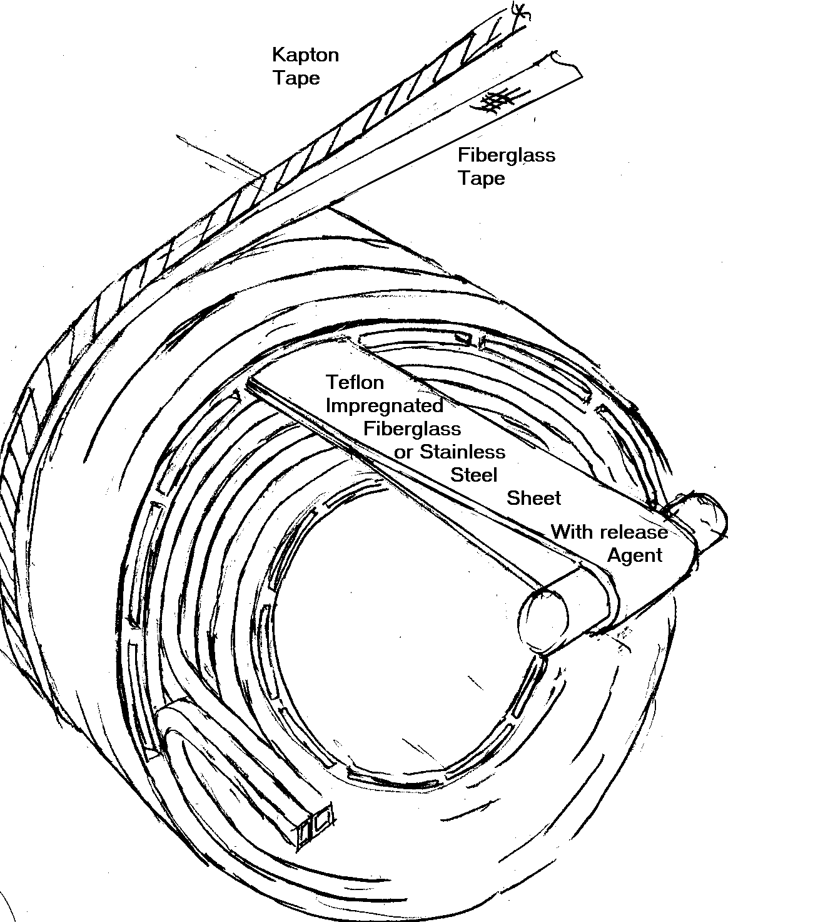Insulation design impacts the conduction cooling behavior:
- Kapton is the limiting element in the thermal conduction through the coil.
- Kapton initially was expected to be wound around the conductor. This produced the equivalent of 5 mils of Kapton between layers.
- To improve conduction, Kapton is used only between the layers. Turn to turn voltage is lower than layer to layer. The turn to turn voltage is less than the rule of thumb for He breakdown voltage (1 volt/mil at 1 atmosphere) for the insulation thickness proposed. Note that the He operating pressure is expected to be 15 atmospheres, the pressures inside the epoxy winding pack may be substantially lower, depending on Helium diffusion, making the 1 atm breakdown voltage for the conductor, reasonable.
- The layer to layer voltage exceeds this rule of thumb, however, and would need the Kapton if there was an imperfection in the epoxy/glass insulation. Half laps of kapton and fiberglass, similar to the CS model coil will retain some structural integrity.
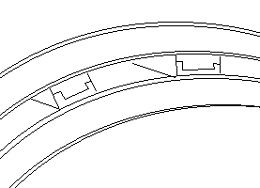
Ribs that form the channels may need
to have sliding parting planes to allow
axial and radial motion between coil
segments.
- Once a layer of conductor is wound, a layer of Kapton/glass would be wound on the completed layer of conductor. This produces the equivalent of 3 mils of Kapton rather than 5 if the conductor were wrapped individually. Every 6 to 8th layer some sort of preformed channel array would be layed on, then wrapped with glass/Kapton to hold it in place, and as the layer insulation for the next layer of conductors. .

Experience with Alcator C-Mod indicates that for final magnet temperatures at or below 100K, the channels will not need “turbulators” or surface trips to break-up the film boiling layer. This will have to be reviewed during the design phase. If some form of surface roughness will be required in the 2mm channels, then the method of forming the channels with removable strips will have to be re-visited.

Engineering Tasks

While the magnet has been conceptualized, with some analytic basis, detailed engineering will require additional work after the construction of the magnet is approved. These tasks are outlined below.

- Identify Voltages for All Operating Scenarios - Choose insulation systems. Determine where Kapton is used.
- Stress Analysis, Assess radial load on channel ligaments, consider operation with inner modules energized, and no current in outer module
- Confirm cooldown and pressure drop calculations
- Analyze thermal contraction/shock of channel – Avoid separation and loss of conduction
- Design He can for 15 atm. and vacuum operation.
- Design mandrel and flow plenums
- Cryostat Design. Is this a Vacuum Cryostat with LN2 Shield, or a Gaseous N2?
- Break-outs and Leads Penetration design – Design the required support to resist loads and torques that result from principally the end radial Field.
- Determine if Eddy Currents in He Can represent a significant load.
- Design Cryogenic Electrical Breaks
- Design Supports, Break-outs, He can and Cryostat to Allow Phased Construction

Some of the analytic work in support of the present design is now described:.

Stress Analysis

The coil is stress analyzed using ANSYS. Fields and forces are computed using Elliptic integrals in a code external to ANSYS. The model is axisymmetrric. The figures show a 3D representation from a symmetry expansion.
Coil Build used in the Stress Analysis
Seg# | r | z | dr | dz | nx | ny
1 | .15 | 0 | .098 | 1.0 | 16 | 16
chan | .2 | 0 | .002 | 1.0 | 1 | 16
2 | .25 | 0 | .098 | 1.0 | 16 | 16
chan | .3 | 0 | .002 | 1.0 | 1 | 16
3 | .35 | 0 | .098 | 1.0 | 16 | 16

For Fusion magnets the inner skin of the solenoid is allowed to reach the yield - Treating this stress as a bending stress with a 1.5*Sm allowable with Sm based on 2/3 Yield.

Interpolated values:, Work hardened copper-, OFHC c10100 60% red
temp deg k | 77 | 90 | 100 | 125 | 150 | 200 | 250 | 275 | 292
yield | 374 | 369. | 365. | 356. | 347. | 328. | 317. | 312. | 308.
ultimate | 476. | 466. | 458. | 439. | 420. | 383. | 365. | 356. | 350.
If the highly cold-worked copper is chosen for the winding, the conductor allowable near the inside radius of the coil would be 365MPa. The max stress in the three segment coil is 166 MPa. With this stress level, it is expected tthat half hard copper could be used, simplifying the winding process.
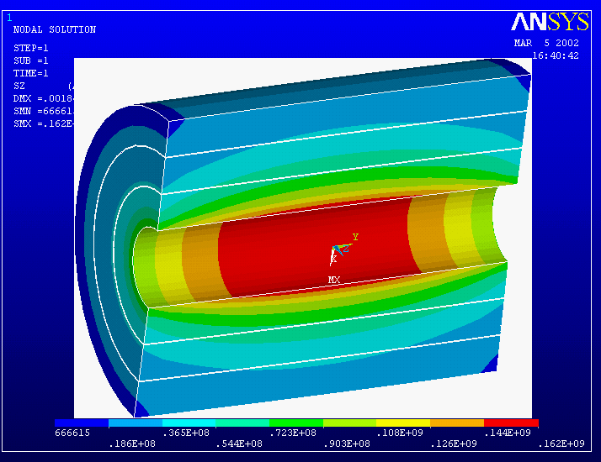
Hoop Stress, all coil segments fully energized. The Von Mises stress plot is similar with a peak of 165 MPa, Tresca is 166 MPa.
The three segment coil has three operational modes, two of which are structurally significant. The full performance configuration is limiting in terms of hoop stress and equivalent stress. It also has some radial stresses that will have to be mitigated with parting planes at the segment boundaries, or within the winding.

In the initial operating mode the outer coil segment is not energized. This induces some differential Lorentz forces and differential temperatures, that cause shear stresses between segments.

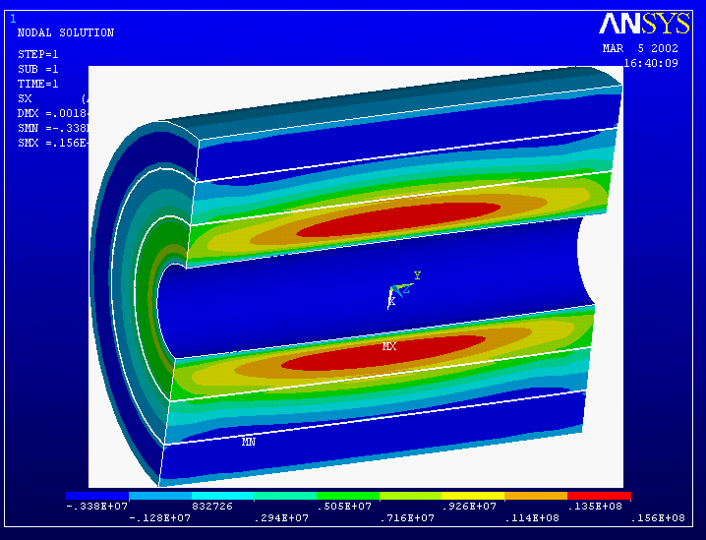
Radial tension stress, all coils fully energized. There is about an MPa of tension at the boundary between the first and second module. To avoid damage to the channel ligaments, a parting plane will be incorporated in the channel detail. This needs to occur in the ligament to retain thermal connection with the coolant in the channel.

It may be desirable to build only the initial two inner segments and add the outer segment at a later time. The coil was analyzed with the outer segment removed, and the same current density in the other two segments. The max stress for this case is 85.3 MPa, which is a bit more than with the outer segment in place, but less than for the fully energized three segment coil. In all cases the stresses are lower than the expected allowable for the conductor. It is expected that the degree of cold work can be relaxed from the full hard condition. The final choice of the degree of cold work for the conductor will be determined during detailed design.
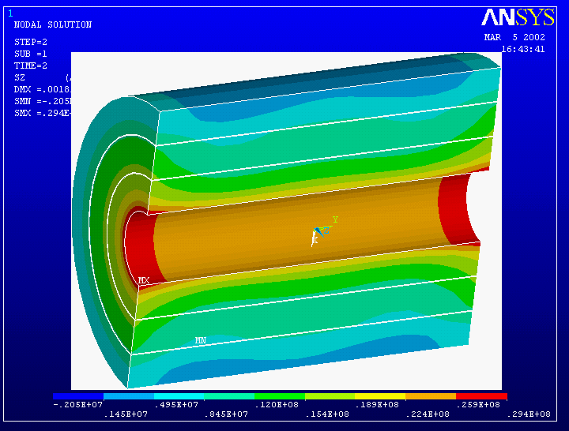
Hoop Stress with only the inner two segments energized.
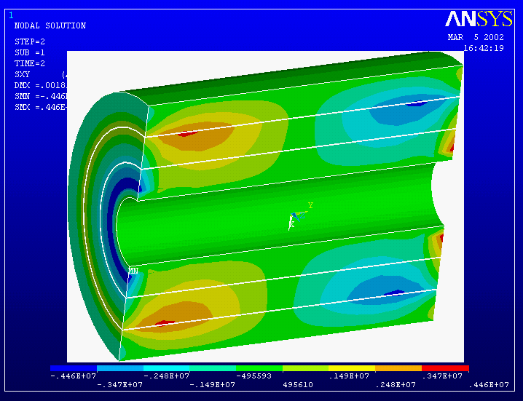
Smeared radial-axial shear stress with the inner two segments energized. This is a peak at the interface between the second and third modules. It must be carried across the thin ligaments between the channels, or relieved via a slip plane.

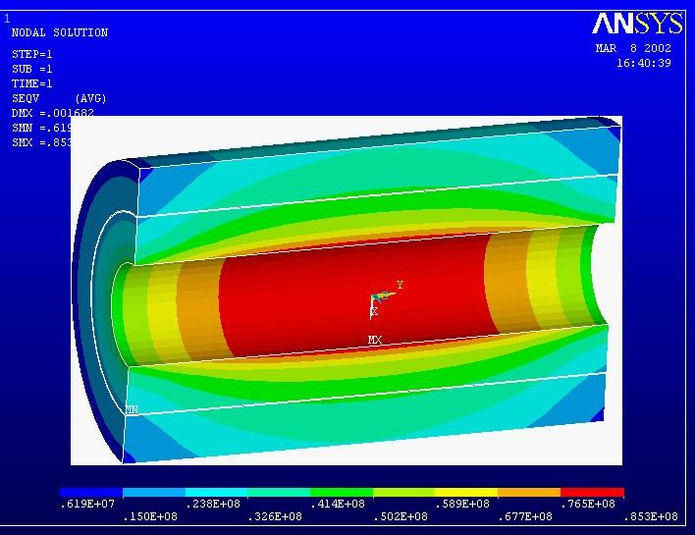

Cooldown Between Shots

Phased implementation of cooling systems is expected for the project. Within the coil, two cooldown methods are being investigated: and option using liquid nitrogen and an option which uses helium gas. It is expected that design of the magnet and cooling channels will allow either working fluid. Use of liquid nitrogen as the only coolant is contemplated for the initial operation of the magnet. It is possible to use the container around the magnet as a vacuum vessel, and sub-cool liquid Nitrogen to 66K. Helium gas operation uses liquid nitrogen to cool the helium gas in a heat exchanger, and later allows use of liquid hydrogen to cool the helium and obtain improved fields and/or pulse lengths. The heat transfer characteristics of liquid nitrogen operation have only been conceptualized. Heat transfer calculations using gaseous helium will be presented here.
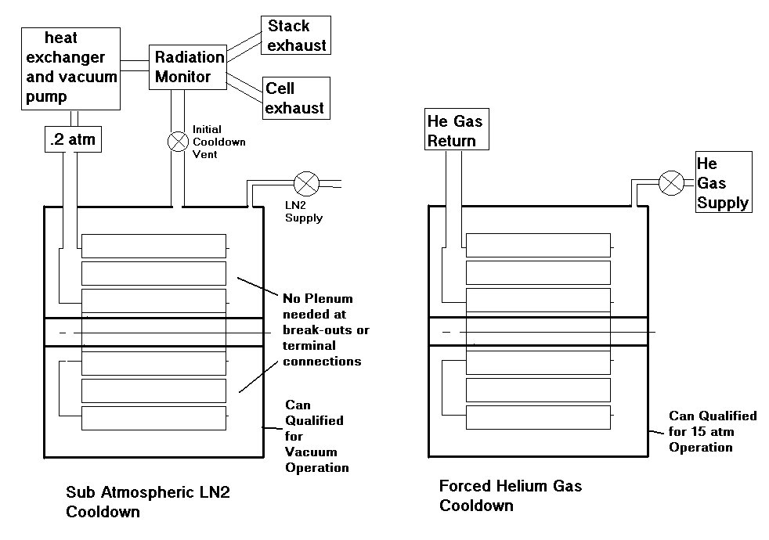
Proposed Operational Modes. The coil and can are designed for either cooling mode

In the LN2 sub-cooling mode, about 50 cubic meter of nitrtogen gas at standard temperature and pressure must be drawn off by the vacuum pump to lower both the magnet and the liquid nitrogen to the desired 66K temperature.
Cooling time with Helium gas as a Working Fluid
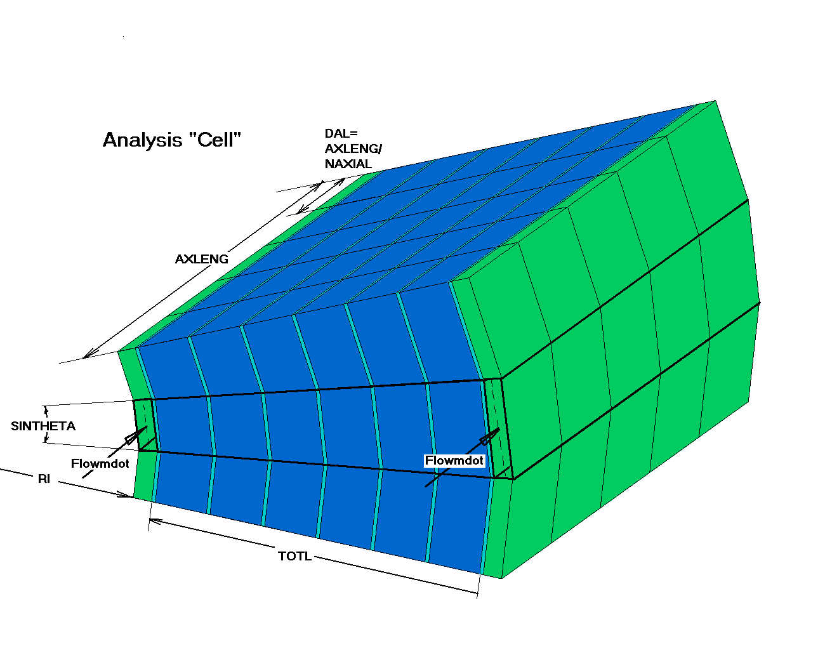

The solenoid has groups of 6 to 8 layers of 1/2 inch square conductors separated by set of annular cooling channels. This could model any linear stack of .5 inch square conductors cooled from the ends of the stack whether layer wound - then there would be a layer of channels every sixth layer of conductor, - or pancake wound, where there would be radial channels every sixth pancake. The solution is a simple finite difference transient analysis. The ground wrap or cracked conductor/Kapton tape interfaces have not been modeled

The insulation layer is modeled with five, and as a second option, three, .001" thicknesses of Kapton tape. The thermal conductivity of the tape is about .14 W/(m-K) at 100 k and was taken from " Thermal Conductivity of Polymide Film between 4.2 and 300K With and Without Alumina Particles as Filler" Rule, Smith, and Sparks, NISTIR #3948. August 1990

The surface heat transfer coefficient at the channels was taken as 170 W/m^2 for nitrogen gas at 100K flowing at 40 m/s in a channel with a 2cm hydraulic diameter. This comes from an Oak Ridge CIT report # ORNL/FEDC-85-10 Dist Category UC20 c,d October 1986. The Helium gas coefficient has been calculated from the Nusselt, Reynolds, and Prandle Numbers using the relation quoted in the Oak Ridge document, and will be verified during detailed design..
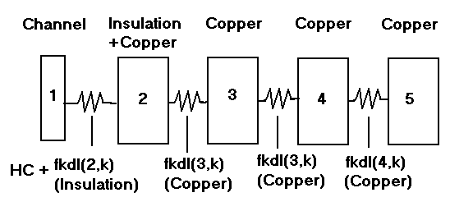
Channel Edge Thermal Model

excerpt from: ORNL/FEDC-85-10 Dist Category UC20 c,d October 1986

Channel Outlet Temps
Bulk Temp

Present Operational Scenarios:
Case # | Peak Field | T after pulse | T coolant | Start Bulk Temp | Guestimated Time
1 | 5T | 90K | 66K | 84K | ~200 sec
2 | 10T | 96K | 66K | 74K | ~800 sec
3 | 15T | 78K | 22K | 30K | ~1500 sec
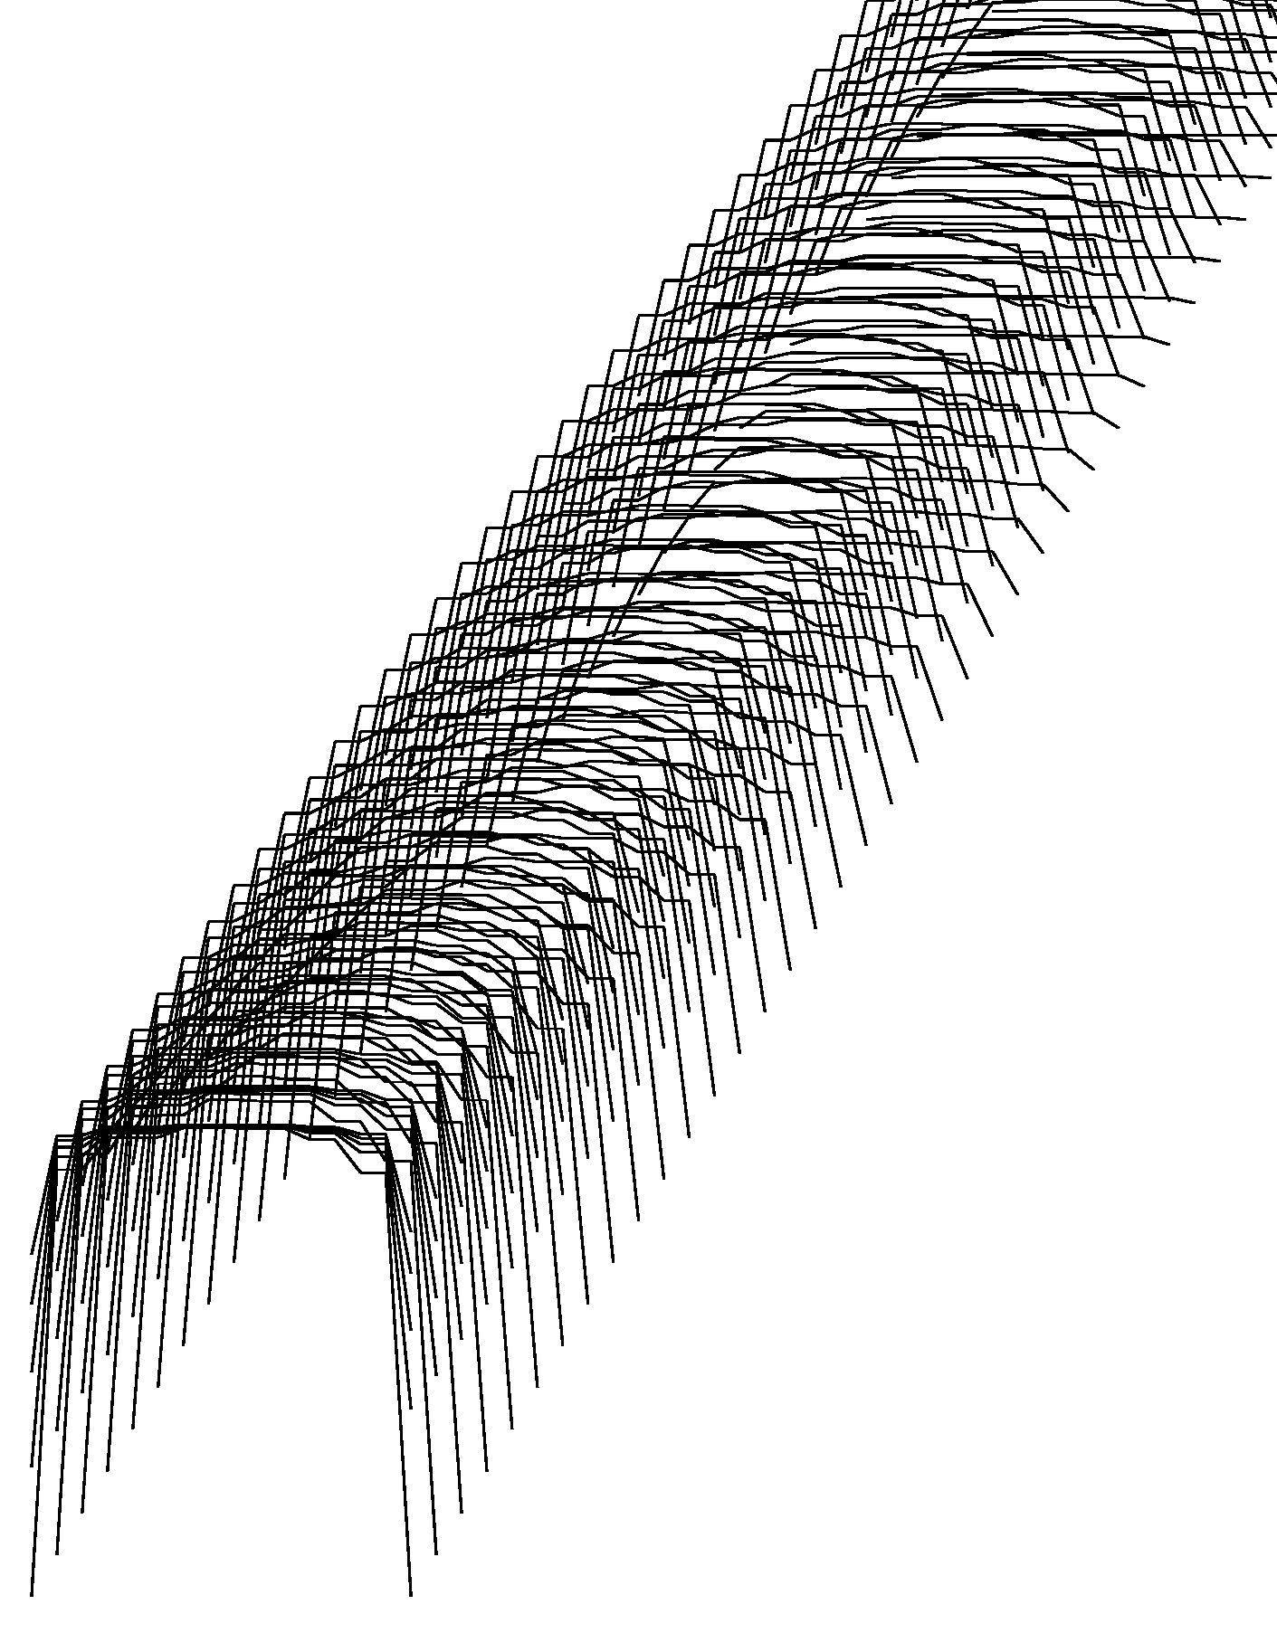
"Cell " Temperature profiles. Time progresses towards the upper rright. The groups of plots are temperature profiles for the five axial stations for which the temperatures are calculated.
Typical results for 66K He cooling, .1kg/sec, 100 K end of pulse temp. 85K target Magnet start temp. The cooldown time is 600 sec. to reach 85K bulk temp, but not thermal equilibrium.

Number of Atmospheres Operating Pressure ;10
Enter Channel Heigth in mm ;2
Rinner, radial build 0.1000000 7.6200157E-02
inner coil start temp 100.0000
outer coil start temp 100.0000
inner coil radius 0.1000000
model cell energy 1644.685J (100 to 85K bulk)
model cell volume 5.5099601E-05
volume cpp 1989954.
nlength, naxial, 120 5
Mass flow rate= 4.1666666E-05kg/sec
Volume flow rate= 5.5507730E-06
flow velocity= 2.120239
Hydraulic Diameter= 2.8944151E-03m
Velocity Head= 1.721665 Pascal
Pressure Drop= 31.46283 Pascal
Pressure Drop= 3.1041747E-04Atmospheres
Helium density= 7.506462 kg/m^3
Helium viscocity= 2.6448268E-07
Prandl #, Reynolds # 4.0756337E-02 174174.1
Heat transfer coefficient 115984. 9

From mdot*cp*deltaT for a 20 deg inlet-outlet difference the cooldown time is about 950 sec. The simulation with a finer time step (dtime=.0001 rather than .001) yields a 600 sec cooldown . The inlet outlet delta T ranges from 26K to 16K. The Energy balance or difference between the conduction heat flux and the channel heat flux. Is good at the finer time step

30K Coolant, Cooldown from 100K


Time in Seconds
Bulk temp
Channel Tout1
Channel Tout2

Bulk temp Is computed as the average temperature at mid axial build - It bottoms out before the down stream end. In the plot above, the channel outlet temperatures are better indicators of when the magnet reaches 30K

tout 1 and tout2 are Outlet Temperatures

Analyses to date: Time to target bulk temp from 100K. ½ inch Copper Conductor.
 | T after  pulse | T  coolant | Cond  Layers | Time to 85K sec | Time to 30K sec
Equiv 5 Kapton .001in wrap | 100K | 66K | 6 layers | 600
Equiv 5 Kapton .001in wrap | 100K | 66K | 8 layers | >850
Equiv 3 Kapton .001in wrap | 100K | 66K | 8 layers | 450
Equiv 5 kapton .0001in wrap | 100K | 30K | 6 Layers |  | 2000

