E951 Targetry R&D Effort - Figures

Beam Window Study Figures

Figure 1: Comparison of measured strains between a 100 KHz and a 500 KHz processed strain signal in the vicinity of the arrival of the initial shock wave at mid-radius of the aluminum window
Figure 2: Strain measured in aluminum window in back-to-back pulses of similar intensity
Figure 3: Cross Correlation of signals in different gauges of the same window to assess the position of the pulse relative to the gauges based on the lag time of stress pulse arrival
Figure 4: Recorded strain in 1mm Inconel window
Figure 5: Predicted strain in 1mm Inconel window
Figure 6: Recorded strain in a 6-mm Inconel window by two strain gauges 180 deg apart. Also shown is the recorded signal by the 100 KHz bandwidth.
Figure 7: Predicted strains in the 6mm-thick Inconel window
Figure 8: Recorded strains in back-to-back pulses in a 11mil-thick Havar window

Figure 9. AGS A3 Line layout at E951 target station

Figure 10. Proton beam focusing at AGS A3 line for experiment E951

Figure 11. Temperature rise from a single pulse in a stainless steel window
Figure 12. von Mises stress in a stainless steel window intercepting a 24 GeV proton beam with 16 TP intensity and 0.5 mm rms spot
Figure 13: von Mises stress wave propagation following a proton pulse in a Inconel-718 window
Figure 14: Verification of the "through-thickness" wave propagation using transient finite element analysis and energy deposition from neutronic calculations
Figure 15: von Mises shock stresses in a Titanium alloy window. Minimum yield stress = 931 MPa
Figure 16: von Mises shock stresses in a 9-mil thick Havar window from a 24 GeV, 16 TP and 0.5 mm rms spot beam. Material yield stress = 1940 MPa
Figure 17: Shock von Mises stresses in an aluminum window similar to beam windows used in the AGS A3 line induced by a 24 GeV proton beam of intensity 16 TP and 1 mm rms spot
Figure 18: Schematic arrangement of the fiber-optic strain gauges in the test windows
Figure 19: Window test set-up at E951 experiment
Figure 20: Radial strain measured in the 10-mil aluminum window and induced by a 24 GeV, 2.5 TP and approximately 1mm rms sigma beam
Figure 21: Predicted strains (ANSYS) in the 10 mil aluminum window for 2.5 TP and 1mm sigma beam

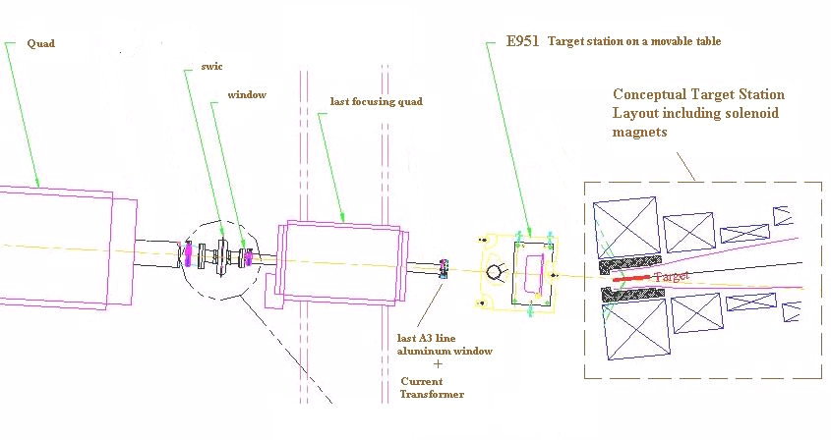

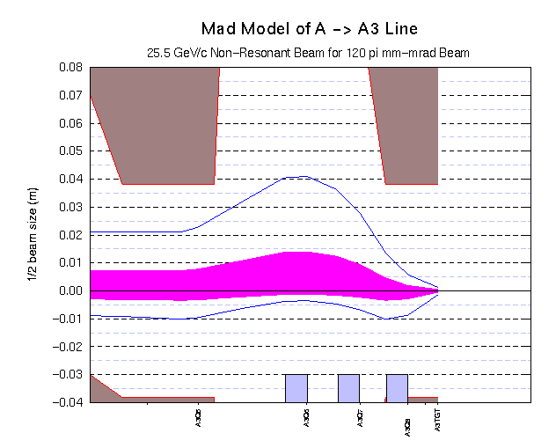

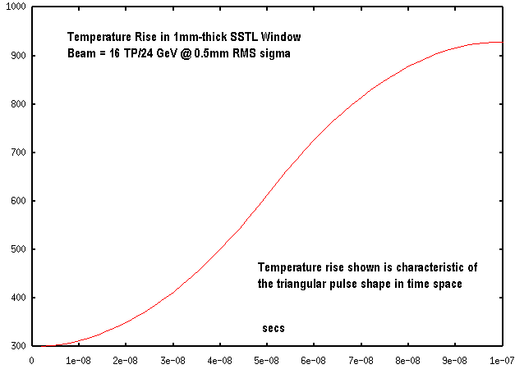

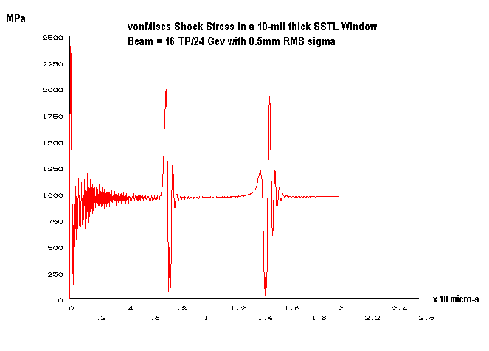

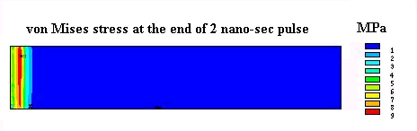
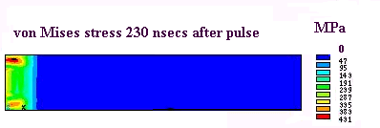
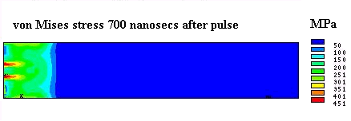
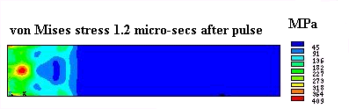

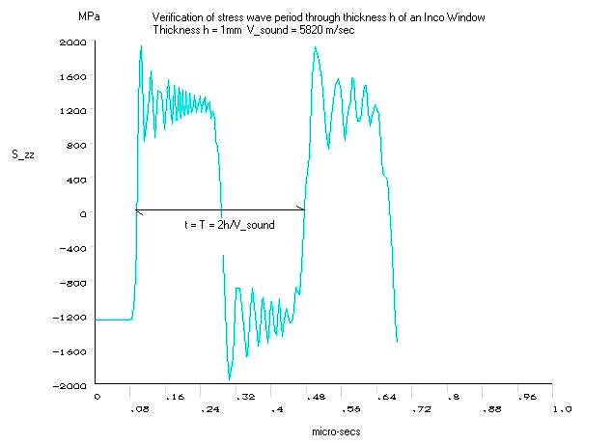

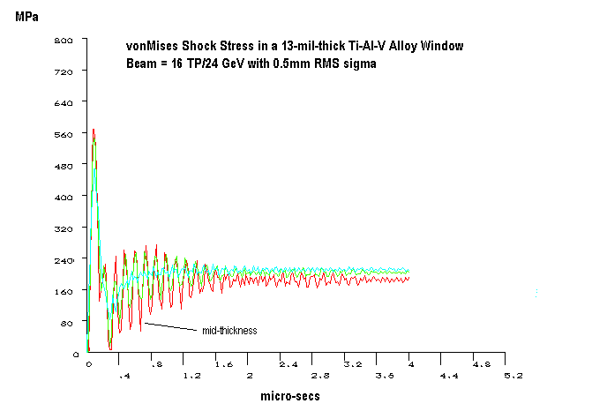

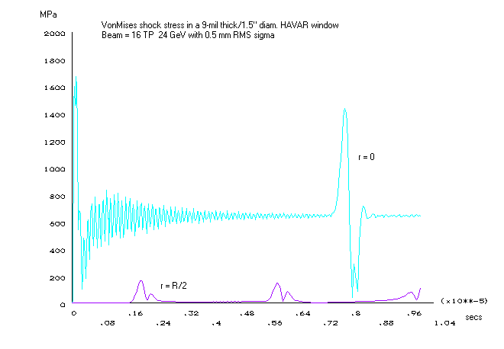

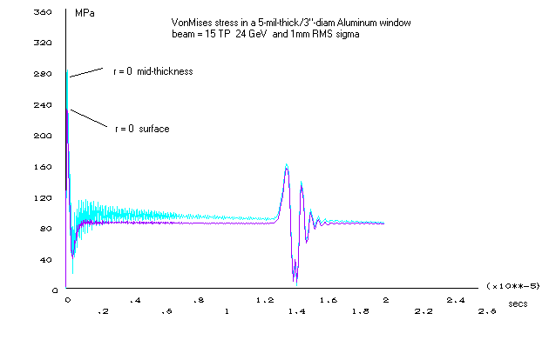

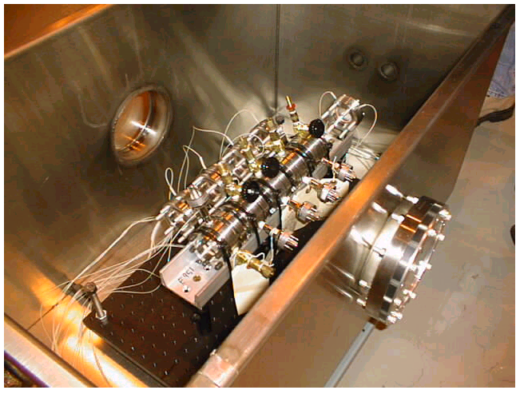
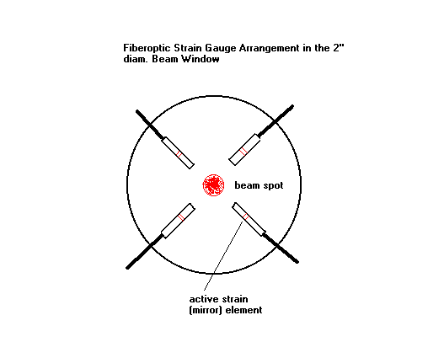

Figure 22
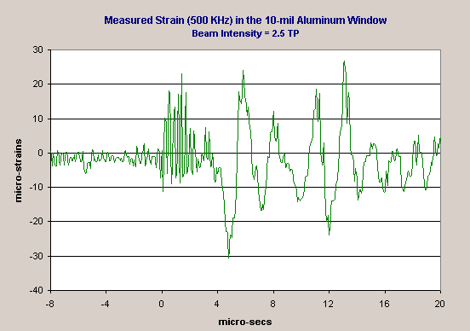

Figure 23

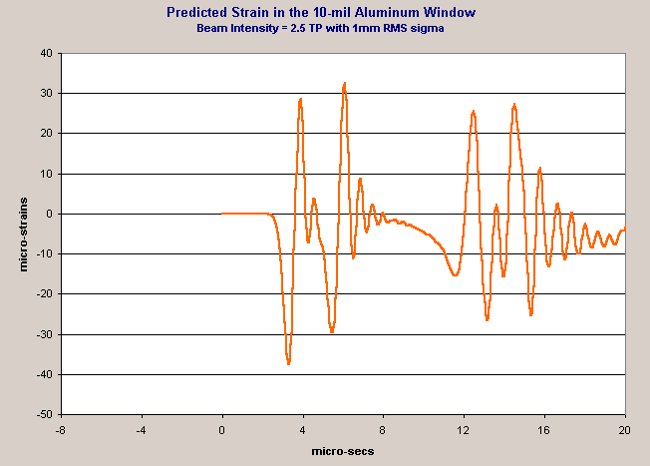
Figure 24
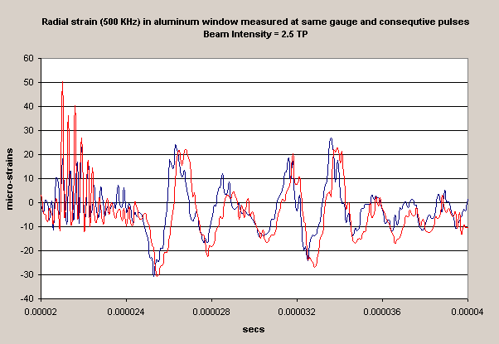

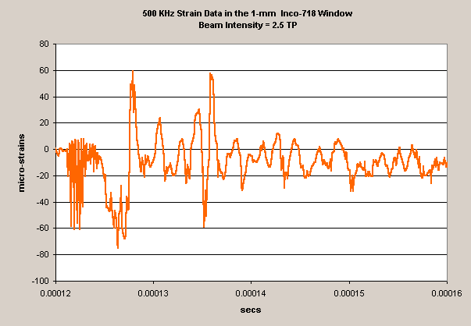

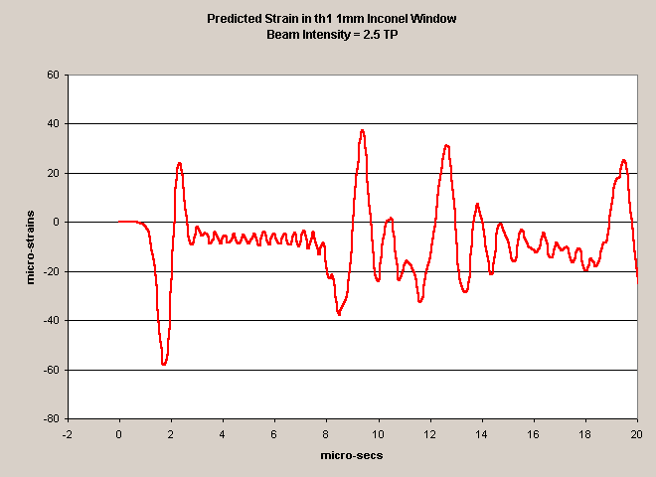

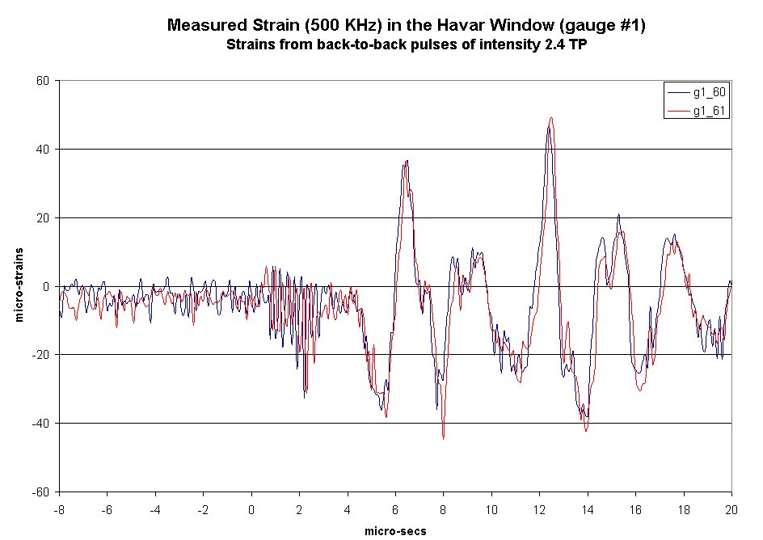

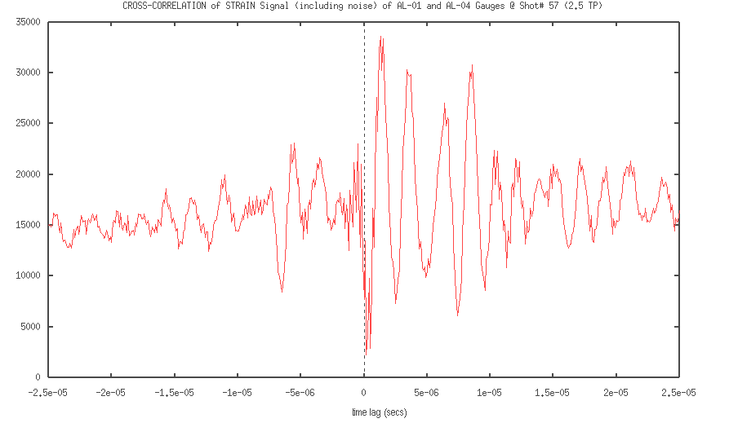

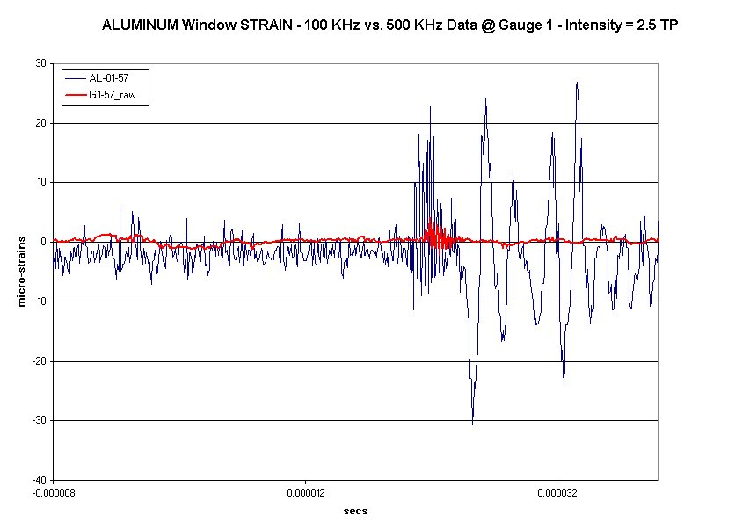
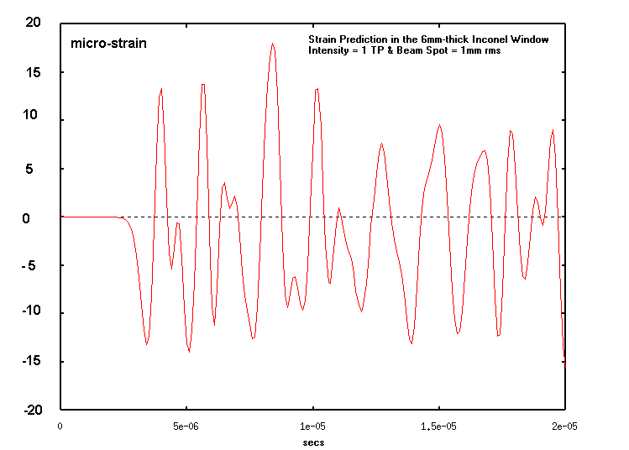

Graphite Targets – Figures

Figure 25:
Figure 26:
Figure 27:
Figure 28:
Figure 29:
Figure 30:
Figure 31:
Figure 32:

Figure 33.

Figure 34.

Figure 35.
Figure 36.

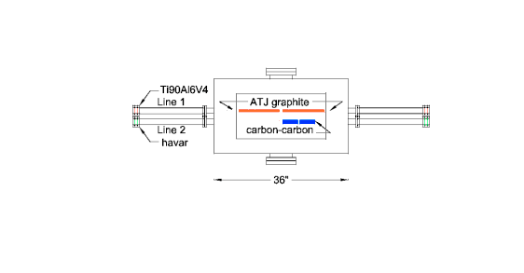

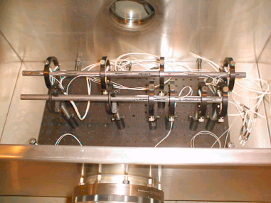

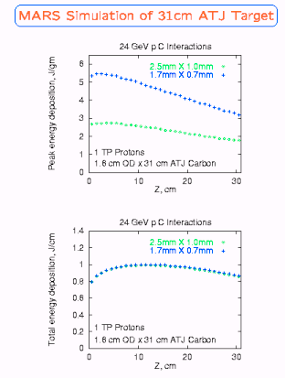

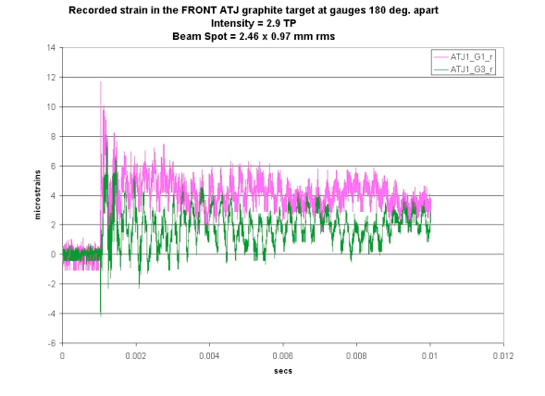

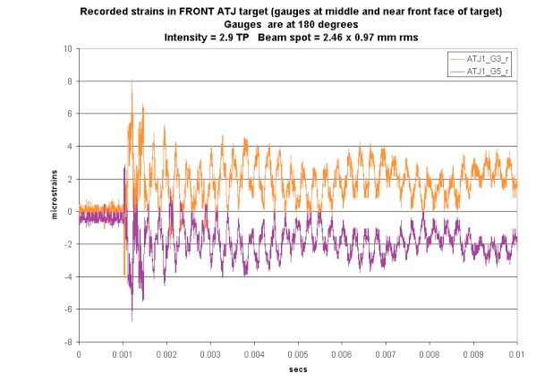

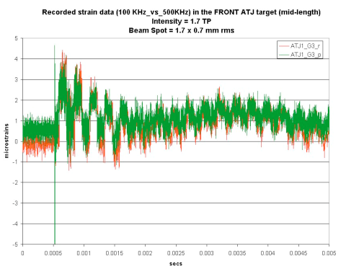

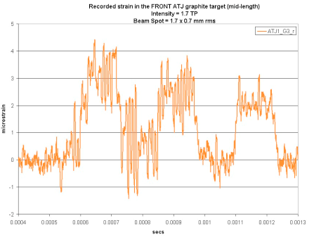

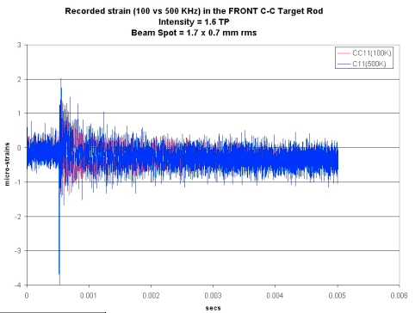

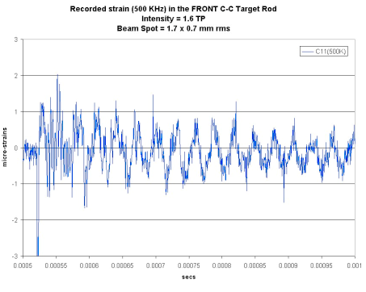

Mercury Target – Figures

Figure 37:
Figure 38:
Figure 39:
Figure 40:
Figure 41:
Figure 42:
Figure 43:
Figure 44:

